CS 255 System Design Document Template

Jodie Snodgrass
6 Aug 2025
CS 255
module 7 project 2

UML Diagrams

UML Use Case Diagram

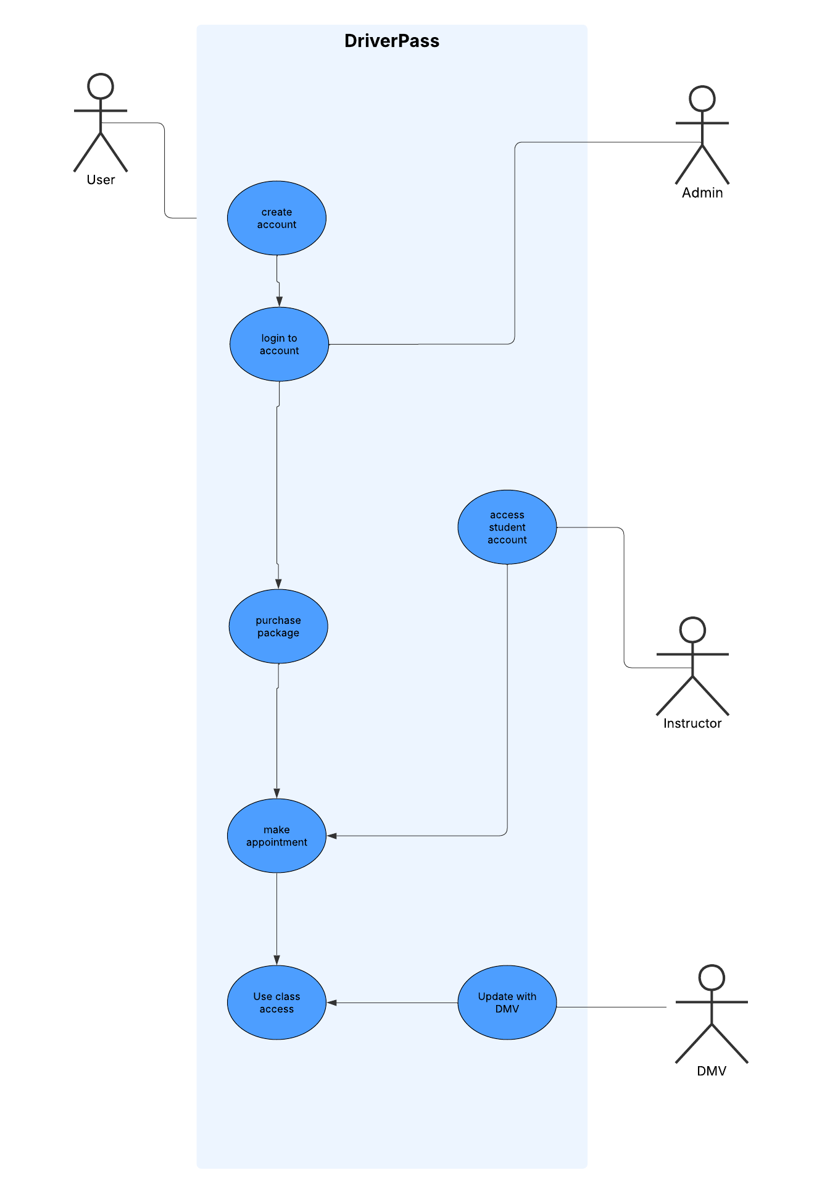

UML Activity Diagrams
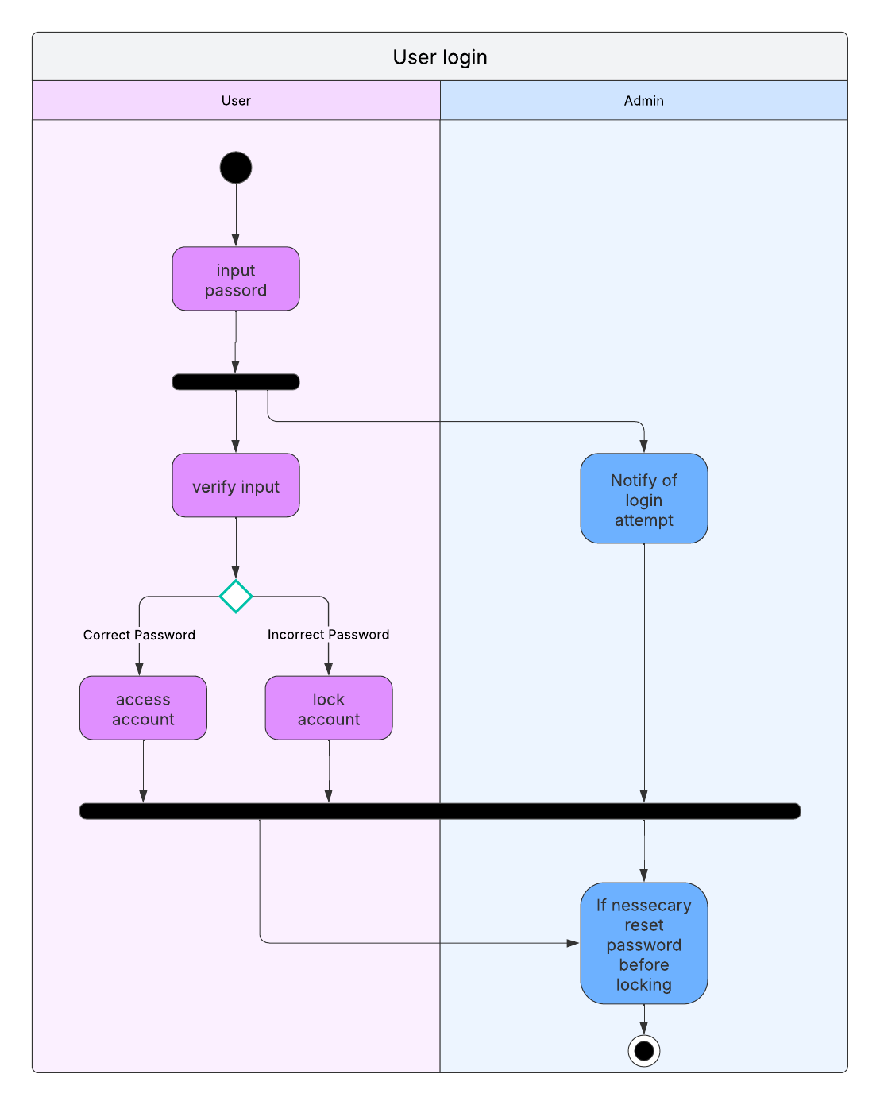
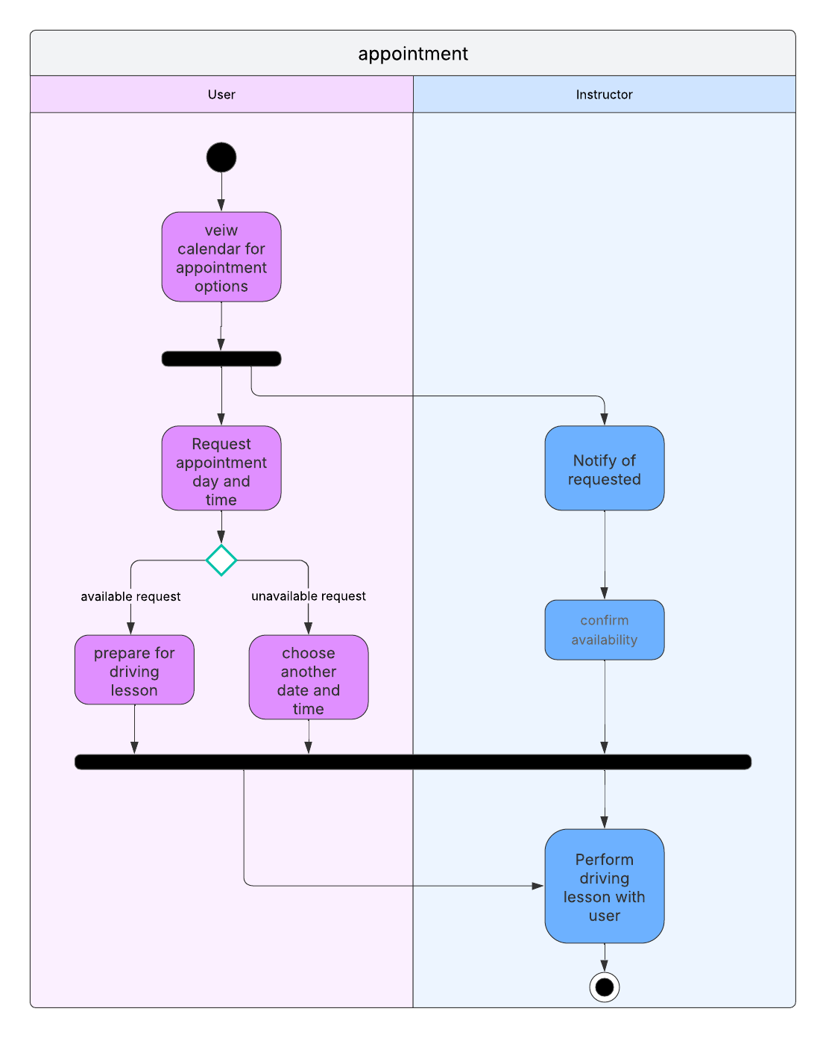

UML Sequence Diagram
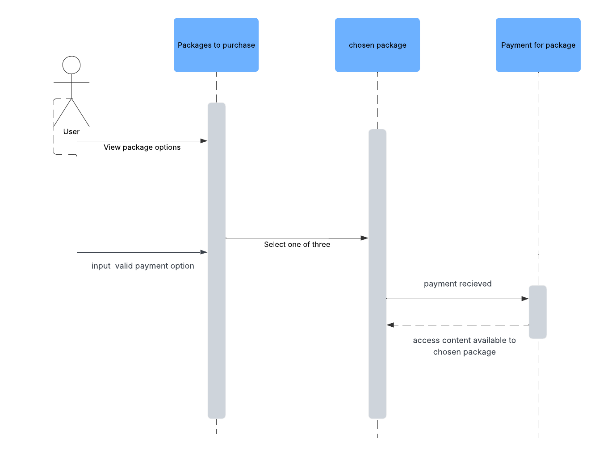

UML Class Diagram
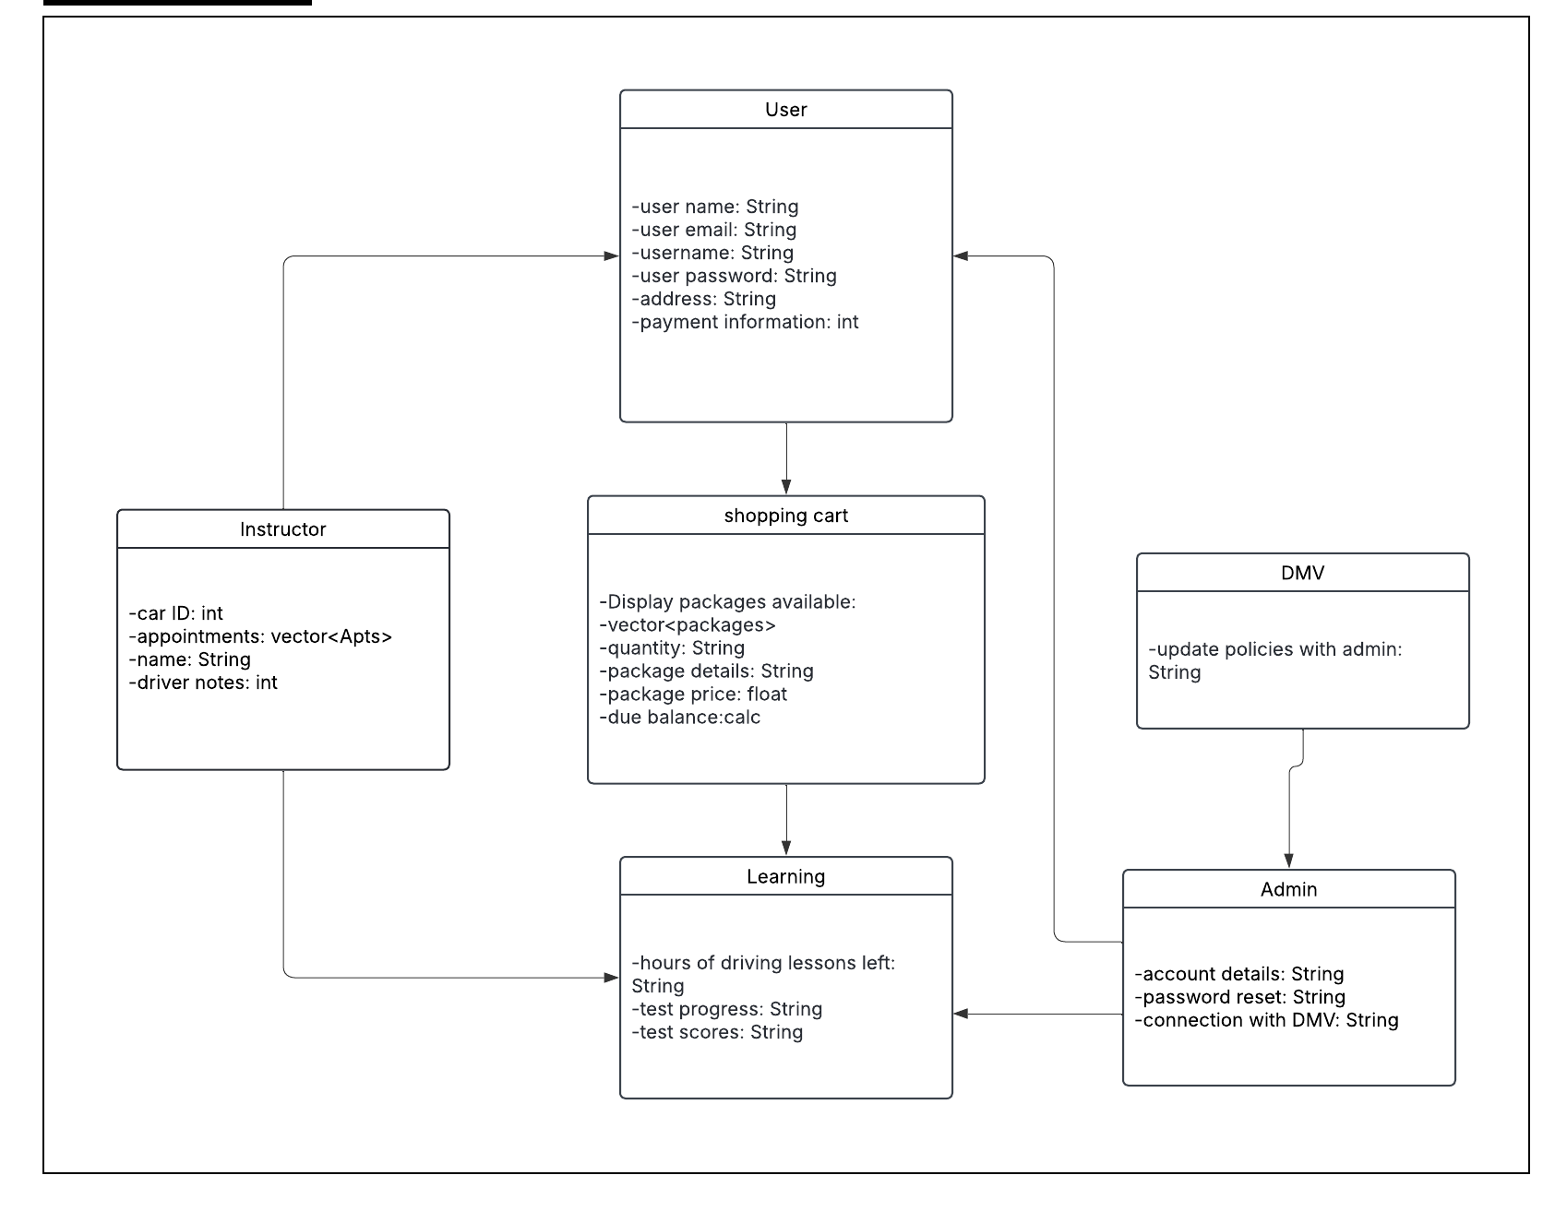

Technical Requirements

There must be employees to teach the users in driving lessons. All ten cars must be in working order and kept up to date with maintenance. There must be a large database to hold all customer and employee information. The users must have a stable internet connection to be able to access the online learning resources, schedule appointments, and be able to purchase a package. The system must have top security to prevent hacking and possible data loss.

